STEP 4: Sensors and board

Board:

As you can see in the list of materials we have used a board with arduino, in particular we have used the SAV-MAKER-I based on the popular vinciDuino board, predecessor of Arduino's Leonardo board and fully compatible with it.

We encourage you to make your own board but if not, you can use an Arduino's Leonardo board.

Then we leave the link to be able to make your own SAV-MAKER-I.

https://github.com/fmalpartida/SAV-MAKER-I

En el proyecto hemos usado los siguientes sensores: sensor de temperatura, sensor de humedad y sensor de luminosidad.

Temperature sensor:

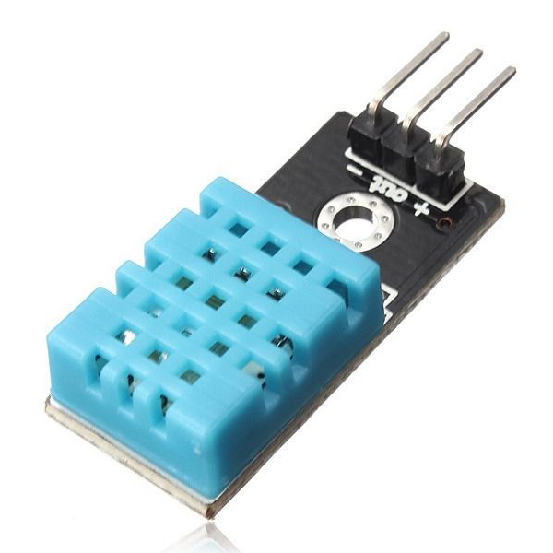

We used a DHT family sensor, specifically the DHT11 model. This sensor is able to provide us digital data of temperature and air humidity. In the project we only measured temperature, but it is interesting for the care of a plant to know the humidity of the air. In the future as we have this sensor we can add this feature to our intelligent plant.

For the programming of this sensor we used the arduino library DHT11. You will need to add the DHT11 library to your Arduino library folder. We include the library for download.

Next, we show a schematic of the sensor connection to the arduino board:

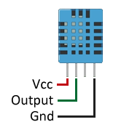

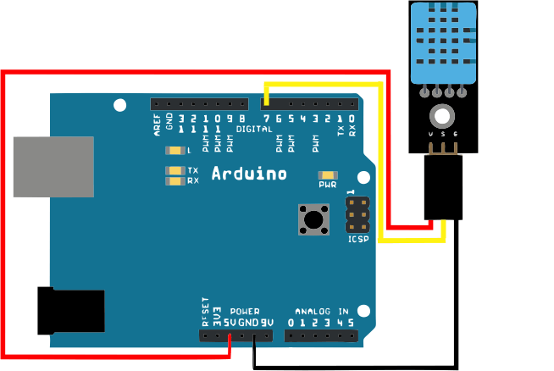

Humidity sensor:

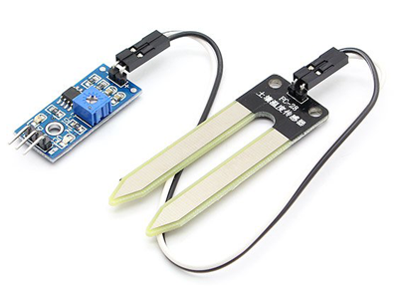

To measure soil humidity we have used a soil hygrometer (FC-28).

The FC-28 is a simple sensor that measures soil humidity varying its conductivity. Does not have enough accuracy to make an absolute measurement of soil humidity, but it is enough for our Project.

The FC-28 is distributed with a standard measuring board that allows to obtain the measurement as an analogue value or as a digital output, activated when the humidity exceeds a certain threshold.

We have used the analog output, the values obtained range from 0 submerged in water, to 1023 in the air (or in very dry soil). A moist soil would give typical values of 600-700. A dry soil will have values of 800-1023.

These values depend of on the plant we have to irrigate, A cactus is not the same as a Calla lily, for most plants these values are valid. We have obtained information from the plant we have used (A thought) and we have used another range most appropriate values.

Now, we show a schematic of the sensor connection to the arduino board.

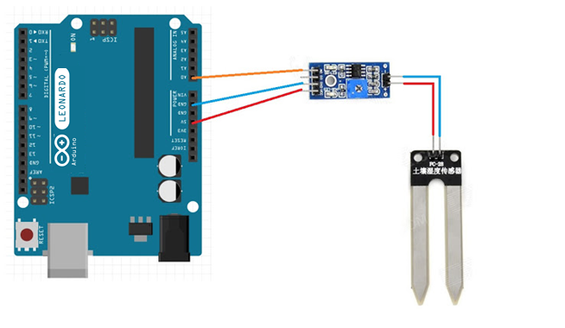

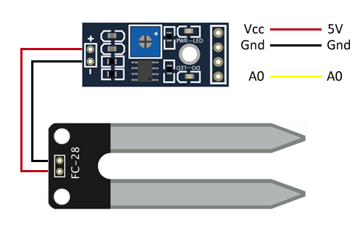

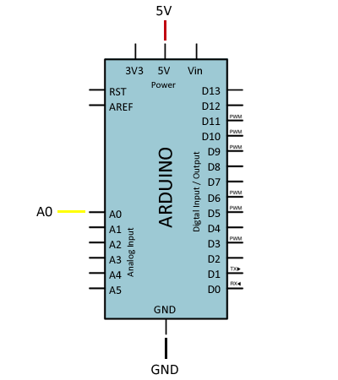

Light sensor:

The light sensor has been manufactured by us. To do this we only need a resistance of 10k Ohms and a photoresistance.

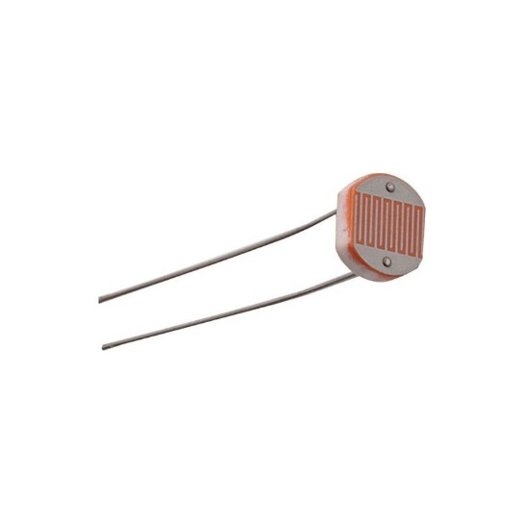

The connection of the sensor to arduino is shown in the following image: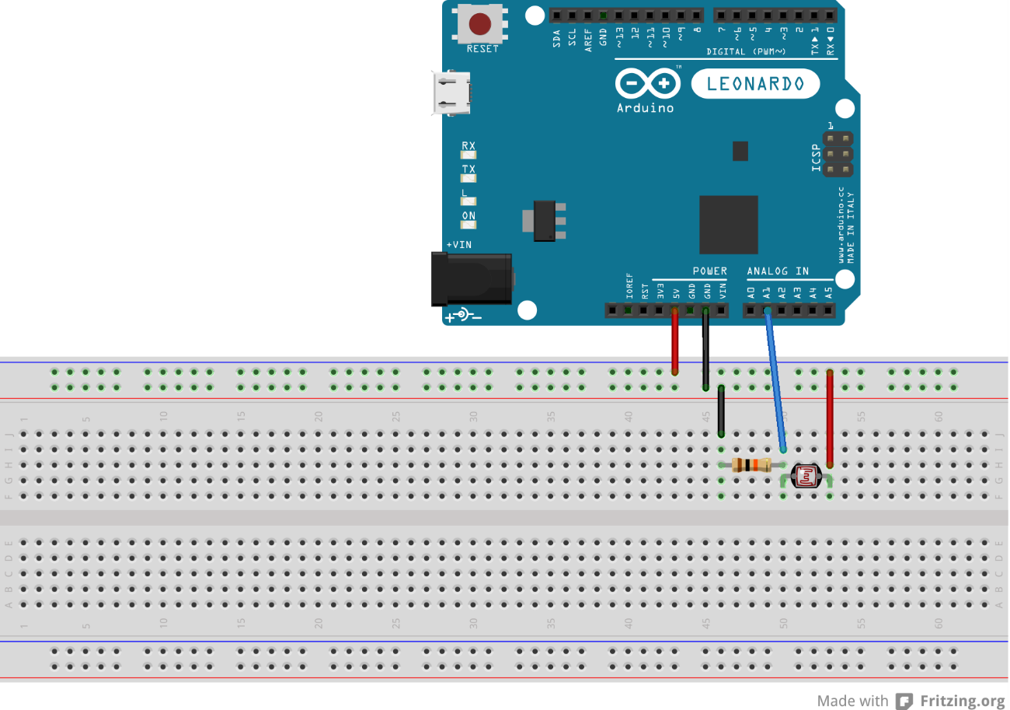

We have soldered the sensor on a Stripboard.

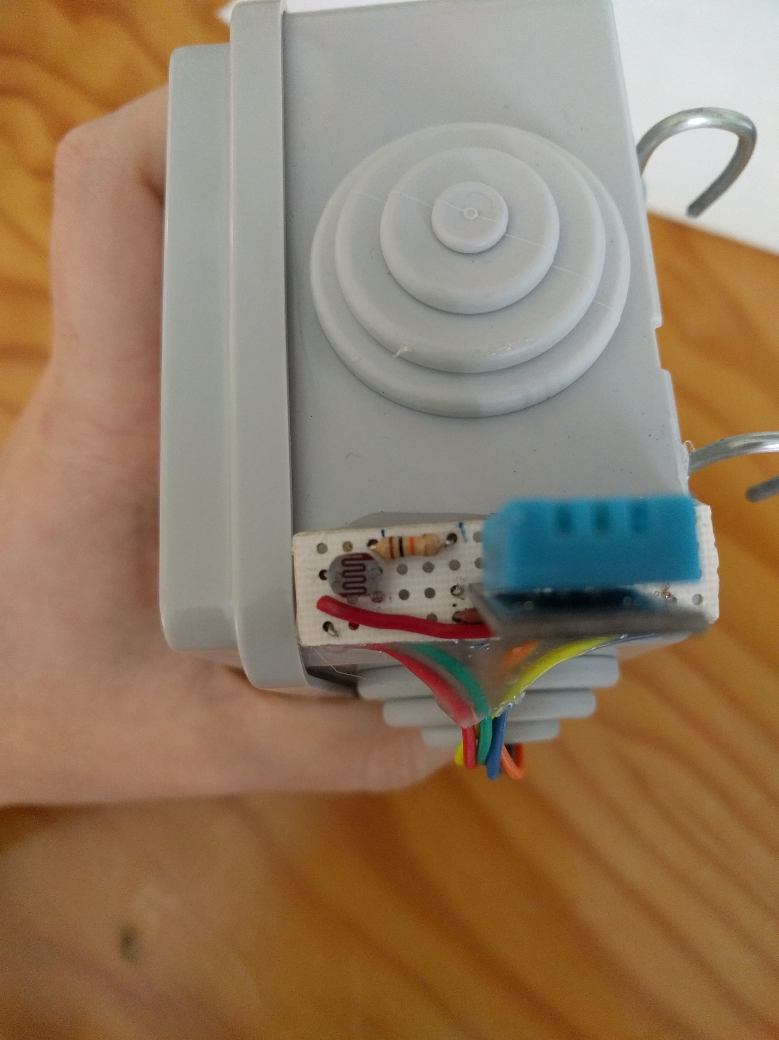

Our plant does not need special care of luminosity. We only use these data when the sun goes to the plant, in this case an output greater than 900 is obtained.